# CHAPTER THREE

## 3.1 INTRODUCTION

“Methodology is the systematic or theoretical analysis of the methods applied to a field of study (research works mainly). It comprises of the theoretical analysis of the body of methods and the principles associated with a branch of knowledge” (accessed on 05 January, 2021).

The design of any research project requires considerable attention to the research methodology, methodology can properly refer to the theoretical analysis of methods appropriate to the field of study, and it also entails a description of the generic processes, as well as analysis of the current system in order to trace the main problems, discuss the findings and specify requirements of the new system.

## 3.2 Sources of Data

The study relied on two sources of data collection which are further discussed below

1. Primary sources: the primary data was obtained through some series of unstructured interviews with some government parastatals admin. We observed many things that help and assisted in putting together this work concerning the necessity of e-Government website usability
2. Secondary sources: the data obtained through these sources was review of past selected e-government websites. Most of which are used in chapter two of the research which gave us an overview/ background knowledge of the proposed topic.

## 3.3 Research Method

There are two basic methods of reasoning: the inductive and the deductive approach. The main difference between these two approaches is that the deductive approach is aimed at testing theory, whereas the inductive approach is concerned with the generation of new theory emerging from the data.



**Gather Data**

*Specific level of focus*



Look for

Patterns

*Analysis*

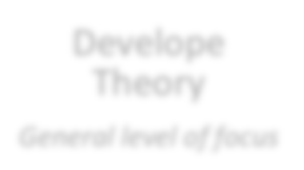

Develope

Theory

*General level of focus*

**Figure 2: Inductive Research**

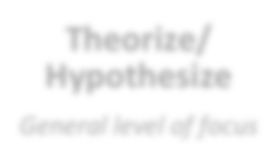

**Theorize/**

**Hypothesize**

*General level of focus*



Analyze Data

*Analysis*



Hypotheses

Supported or Not

*Specific level of focus*

**Figure 3: Deductive Research**

In this study, the researcher has chosen to apply the deductive approach. The researcher starts with a literature review to introduce and define usability, different kinds of usability evaluation methods and to discuss some previous studies on the usability evaluations of e-government portals. This provides basis for theory. By combining the comparison of a variety of usability evaluation methods with the characteristics of Nigerian e-government portals, the researcher chooses the heuristic evaluation method and uses Jakob Nielsen’s 10 heuristic principles to evaluate the usability of the case e-government portal. The researcher presents a brief description of the case and then identifies the usability issues against each principle. At the end, the researcher introduces a list of usability problems and also gives some suggestions for the future construction of e-government portals.

This study applies a qualitative research approach. Contrary to the quantitative method, the qualitative approach generates verbal information rather than numerical values (Polgar & Thomas, 2015). Instead of using statistical analysis, the qualitative approach uses content or holistic analysis to explain and comprehend research findings.

In Creswell’s view (2019), case study research is a type of design in qualitative research which can be an object of study. He defines case study research as:

a qualitative approach in which the investigator explores a real-life, contemporary bounded system (a case) or multiple bounded systems (cases) over time, through detailed, in-depth data collection involving multiple sources of information (e.g., observations, interviews audiovisual material, and documents and reports), and reports a case description and case themes.

The unit of analysis can be an event, a program, an activity or more than one individual. A technical definition of case studies, emphasizing the logic of design, is proposed by (Ajose,2014) as shown below:

A case study is an empirical inquiry that

* investigates a contemporary phenomenon (the “case”) in depth and within its real-world context, especially when
* the boundaries between phenomenon and context may not be clearly evident.

In addition, case studies have a distinctive place in evaluation research (U.S. Government Accountability Office, 1990). There are at least four different applications of case studies. One of the applications is to illustrate certain topics within an evaluation, again in a descriptive mode (U.S. Government Accountability Office, 1990). Thus, for the evaluative purpose, the case study approach was adopted in this research. The e-government portal of the Hubei province (www.hubei.gov.cn) was selected as the case. By evaluating the portal, the usability of Chinese e-government portals can be understood better, and the findings may help to improve the quality of e-government portals.

## 3.4 Method of Data Collection

The study adopted the field and document analysis method of data collection. Data were also collected through unstructured interviews conducted one-on-one and through telephone discussions with known Research Centre In Katsina. However the present manual system of Journal Management is also examined to gather more details.

The overall emphasis is to uncover some of the inherent problems and limitations the existing system has, and to determine the current status of the existing system.

## SDLC MODELS

### 3.5.1 Waterfall Model

Waterfall is the oldest and most straightforward of the structured SDLC methodologies finish one phase, then move on to the next. No going back. Each stage relies on information from the previous stage and has its own project plan. Waterfall is easy to understand and simple to manage.

But early delays can throw off the entire project timeline. And since there is little room for revisions once a stage is completed, problems can’t be fixed until you get to the maintenance stage. This model doesn’t work well if flexibility is needed or if the project is long term and ongoing.

### V-Shaped Model

Also known as the Verification and Validation model, the V-shaped model grew out of Waterfall and is characterized by a corresponding testing phase for each development stage.

Like Waterfall, each stage begins only after the previous one has ended. This model is useful when there are no unknown requirements, as it’s still difficult to go back and make changes.

### Iterative Model

The Iterative model is repetition incarnate. Instead of starting with fully known requirements, you implement a set of software requirements, then test, evaluate and pinpoint further requirements. A new version of the software is produced with each phase, or iteration. Rinse and repeat until the complete system is ready.

One advantage over other SDLC methodologies: This model gives you a working version early in the process and makes it less expensive to implement changes. One disadvantage: Resources can quickly be eaten up by repeating the process again and again.

### Spiral Model

One of the most flexible SDLC methodologies, the Spiral model takes a cue from the Iterative model and its repetition; the project passes through four phases over and over in a “spiral” until completed, allowing for multiple rounds of refinement.

This model allows for the building of a highly customized product, and user feedback can be incorporated from early on in the project. But the risk you run is creating a never-ending spiral for a project that goes on and on.

### Big Bang Model

A bit of an anomaly among SDLC methodologies, the Big Bang model follows no specific process, and very little time is spent on planning. The majority of resources are thrown toward development, and even the client may not have a solid grasp of the requirements. This is one of the SDLC methodologies typically used for small projects with only one or two software engineers.

Big Bang is not recommended for large or complex projects, as it’s a high-risk model; if the requirements are misunderstood in the beginning, you could get to the end and realise the project may have to be started all over again.

### Agile Model

By breaking the product into cycles, the Agile model quickly delivers a working product and is considered a very realistic development approach. The model produces ongoing releases, each with small, incremental changes from the previous release. At each iteration, the product is tested.

This model emphasizes interaction, as the customers, developers and testers work together throughout the project. But since this model depends heavily on customer interaction, the project can head the wrong way if the customer is not clear on the direction he or she wants to go.

### ADOPTED METHODOLOGY

Research methodology (System methodology) can be defined as the methodologies, processes, and frameworks range from specific proscriptive steps that can be used directly by an organization in day-to-day works, to provide flexible frame works that an organization uses to generate a custom set of steps tailored to the needs of a specific project or group (Girish 2015). There are quite a number of research methods, but choice is strictly dependent on the nature and type of the research to be carried out. Being this project software based, which is also within the context computer science, the Waterfall model will be used in developing this project.

**Waterfall Model: -** The Waterfall Model was the first Process Model to be introduced. It is also referred to as a linear-sequential life cycle model. In a waterfall model, each phase must be completed before the next phase can begin and there is no overlapping in the phases. This model will be used for this research. The following illustration is a representation of the different phases of the Waterfall Model (Herbert D, 1983).

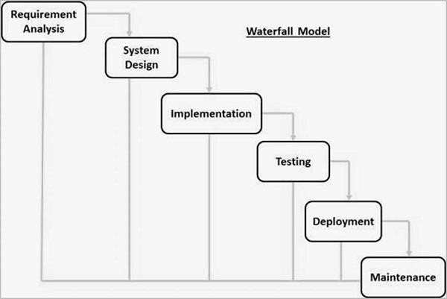

***Fig 3.1 Waterfall Model (Arcisphere technologies, 2012)***

The waterfall Model illustrates the software development process in a linear sequential flow. This means that any phase in the development process begins only if the previous phase is complete. In this waterfall model, the phases do not overlap (Arcisphere technologies, 2012).

According Douglas. I. (2009). The sequential phases in Waterfall model are −

* **Requirement Gathering and analysis** − All possible requirements of the system to be developed are captured in this phase and documented in a requirement specification document. The source of the data will be the Project Coordinator of the department.
* **System Design** − the requirement specifications from first phase are studied in this phase and the system design is prepared. This system design helps in specifying hardware and system requirements and helps in defining the overall system architecture.
* **Implementation** − with inputs from the system design, the system is first developed in small programs called units. Each unit is developed and tested for its functionality, which is referred to as Unit Testing. The implementation of this system will be using the PHP.
* **Integration and Testing** − All the units developed in the implementation phase are integrated into a system after testing of each unit of the software. Post integration the entire system is tested for any faults and failures.
* **Deployment of system** − Once the functional and non-functional testing is done; the software will be deployed for the university to use.
* **Maintenance** − finally, there are some issues which come up with software. To fix those issues, patches are released. Also, to enhance the software some better versions are released. Maintenance is done to deliver these changes in the software

## 3.6 WEB-DESIGN METHODOLOGY

The new system to be developed for this research project is a web-based system. The methodology used in this research is Web-site Design Methodology (WSDM). Achebe (2002) stated that there are five phases in web-site design methodology which are:

1. Mission Statement
2. Audience Modeling
3. Conceptual Modeling
4. Implementation design
5. Actual Implementation

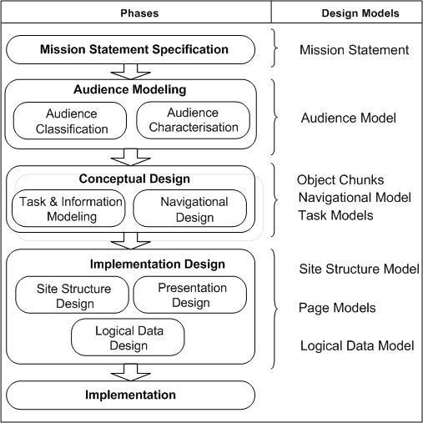 ***Figure 3.1: Web-based design method phases***

**3.6.1 MISSION STATEMENT:** The Mission statement also known as the “*Mission Statement*

*specification*, is the first phase in web-based design methodology. It attempts to provide answer to the questions; what is the purpose of the web application, what is its subject and ho are the target audience? Once the above questions are answered, that means the mission statement phase is completed.

**3.6.2 AUDIENCE MODELING:** This phase comprises of two sub-phases which are audience classification and audience characterization; At Audience classification, Audience classes are identified by considering only the activities of the organization related to the purpose of the project and identifying the people involved; these people can now be grouped into audience classes by looking at those information and functional requirements that are similar to them. Lastly, at the Audience characterization, the characteristics of the various audience classes are given.

**3.6.3 CONCEPTUAL MODELING:** This is also known as the conceptual design phase. It consist of three parts that can be performed simultaneously; Information modeling, functional modeling and navigational design. ***Information modeling*** is mainly intended for data intensive web sites; it deals with the “conceptual what” i.e. the type of information and how it is structured. ***Functional modeling*** consists of the interaction between the users and the system. For the purpose of the interaction, the functional requirements are listed according to the various audience classes based on how they are related to the system. Lastly, ***Navigational Design*** addresses how to navigate through the information. Each audience class is considered and the various information components external that are related to it are considered. The integration of Information, functional modeling and navigational model is known as ***Conceptual Modeling.***

**3.6.4 IMPLEMENTATION DESIGN PHASE:** The Implementation Design Phase is a three phase model that comprises Page structure design, Presentation design and Logical Database design. ***Page structure design*** entails packaging information in form of chunks in the right proportions. ***Presentation Design*** deals with the „*look and feel’* of the web site. And may constitute a lot of literature. Lastly, ***Logical Database Design*** is the design of the underlying database that may be used to maintain the data in case of data intensive web applications. The output of the implementation design is an implementation model.

**3.6.5 IMPLEMENTATION PHASE:** The implementation phase is concerned with realizing the web applications by using the design made in the previous phases.

This project research is going to use the above methodology for the design of the online system for Katsina International Journal of Counselling Psychology (SIJCP). The diagram in figure 3.1 shows all the phases discussed in the methodology above.

## 3.7 Research Problem

This study evaluates the usability of e-government portals in Nigeria and aims to introduce usability issues to government administrators and to give suggestions on how to improve the quality of e-government portals. The data is based on the evaluation of the e-government websites of Nigeria. The portal can be used as an example in identifying usability issues.

## 3.8 Employing Design Science in Research

Design Science is an information communication technology (ICT) research methodology, which supplies researchers or reviewers with specific guidelines for evaluation and iteration within research projects. Design science research is always applied to assess or evaluate the development and performance of an (designed) artifact with the purpose of improving the functional performance of the artifact. (Hevner et al., 2018.)

In this study, the aim is to evaluate the usability of Nigerian e-government portals and detect usability issues. Thus, the researcher employs design science, as the evaluation object is a case e-government portal. The selected model of design science is the one presented by Hevner et al. (2018) as below (Figure 1):

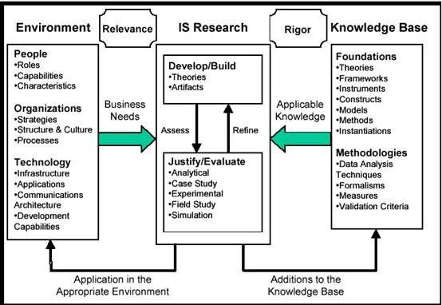

**Figure 1: Design Science Research Model (Hevner et al., 2018)**

In this case, the “People” in the research environment are the Nigerian citizens who are using the e-government portal. The “Organizations” are the government departments which are responsible for the construction of the Nigerian e-government. The “Business Need” of e-government portals is to provide online government information and services for Nigerian citizens. In addition to the environment part, the study needs to apply the knowledge base which is divided into “Foundations” and “Methodologies”. More specifically, the theory within “Foundations” is theoretical information about usability, usability evaluation methods and e-government portals. The “Methodologies” refer to the research methods applied in this study, including the research approach, the data collection method, and the data analysis method.

There are seven guidelines for design science, including “Design as an Artifact”,

“Problem Revelence”, “Design Evaluation”, “Research Contributions”, “Research Rigor”, “Design as a Search”, and “Communication of Research”. When discussing the design science guidelines, Hevner et al. (2018) indicate that IT artifacts can be evaluated in terms of functionality, completeness, consistency, accuracy, performance, reliability, usability, fit with the organization, and other relevant quality attributes.

Since the aim of this study is to evaluate the usability of e-government portals, the researcher follows the Design Evaluation Guideline. The design evaluation methods are listed in Table 1.

|  |  |
| --- | --- |
| 1. Observational | Case Study: Study artifact in depth in business environment |
| Field Study: Monitor use of artifact in multiple projects |
| 2. Analytical | Static Analysis: Examine structure of artifact for static qualities (e.g., complexity) |
| Architecture Analysis: Study fit of artifact into technical IS architecture |
| Optimization: Demonstrate inherent optimal properties of artifact or provide optimality bounds on artifact behavior |
| Dynamic Analysis: Study artifact in use for dynamic qualities (e.g., performance) |
| 3. Experimental | Controlled Experiment: Study artifact in controlled environment for qualities (e.g., usability) |
| Simulation ñ Execute artifact with artificial data |
| 4. Testing | Functional (Black Box) Testing: Execute artifact interfaces to discover failures and identify defects |
| Structural (White Box) Testing: Perform coverage testing of some metric (e.g., execution paths) in the artifact implementation |
| 5. Descriptive | Informed Argument: Use information from the knowledge base (e.g., relevant research) to build a convincing argument for the artifacts utility |
| Scenarios: Construct detailed scenarios around the artifact to demonstrate its utility |

**Table 1: Design Evaluation Methods (Hevner et al., 2018)**

During the evaluation, the researcher uses both the testing and the descriptive method. That is, the researcher executes tasks on the interface of the case e-government portal to discover usability issues. Then, the researcher describes the usability issues and corresponding heuristics. Finally, the researcher presents an argument concerning the usability of Nigerian e-government portals.

.